User Manual

Contents

1- System Overview 1

2- System Requirements 1

3- Getting Started 1

4- Using the system 2

4.1. Sign Up 2

4.2. Log in 3

4.3. Main Page 4

4.4. More Detail 5

4.5. Widget 6

# 1- System Overview

Green Energy Shifting is an application which advises consumers when it is the best time to turn their energy consumers on. It recommends users to shift the usage of energy consumers into the time slots when the amount of green energy is high.

# 2- System Requirements

This application operates on mobile devices with Android operating system. It is compatible with Android 2.2.x (tested on 4.4.x, 4.0.x) API level 8 and higher versions. The application requires connection to Internet in order to save data to database.

# 3- Getting Started

The application can be downloaded from www.greenenergy.veronika-henk.de. After installation on the device, Green Energy Shifting can be used immediately without any further configuration.

# 4- Using the system

Green Energy consists of 4 pages, including Sign up, Log in, Main page and More Details page. There is also a widget for this application.

## 4.1. Sign Up

If you are using this application for the first time, you need to sign up by choosing a username and a password which must be at least 5 characters.

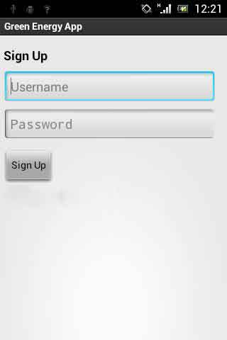

## 4.2. Log in

If the application is launched for the first time, this page will be shown. If you are new to this app, you need to click on Sign Up to register. Otherwise, you just need to log in with your username and password.

It should be noted that you need to log in to the application in order to use it.

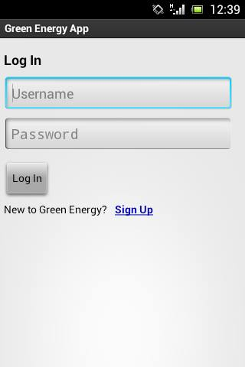

## 4.3. Main Page

In the main page, the current amount of green energy and conventional fuel are shown as well as some predictions.

On the top left side of the page next to your username (2), a score (1) is shown. You get score, each time you use energy in the best times and publish it on Twitter using the Twitter icon (3) on the top right side of the page.

The chart (4) in the center of the view shows the amount of green energy. The chart and the smiley close to it, show if it is recommended to use energy right now or not. At the bottom, there is a part which predicts the amount of green energy in few hours (5). If you want to see more details to know when to use energy, you should click on “More Details” button (6).

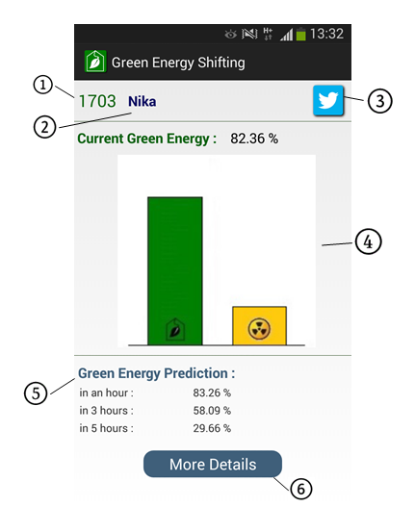

## 4.4. More Detail

Score and username are also shown in this page. If you are logged in to Twitter, you will see the Twitter icon on the top right side of the page.

You will see this page after clicking on “More Details” button which is in the main page. Here you can see hourly green energy prediction. Energy amounts are shown in three different colors. Green shows the best times to use energy, Gray means it is still okay to use energy and Orange means the amount of energy is too low and it is not recommended to use energy at these times.

There is also the possibility to set a reminder for the time you would like to use energy. You can do this by simply clicking on the Clock icons next to each row. It turns blue as it can be seen in the picture below.

Note: You can activate just one reminder at a time.

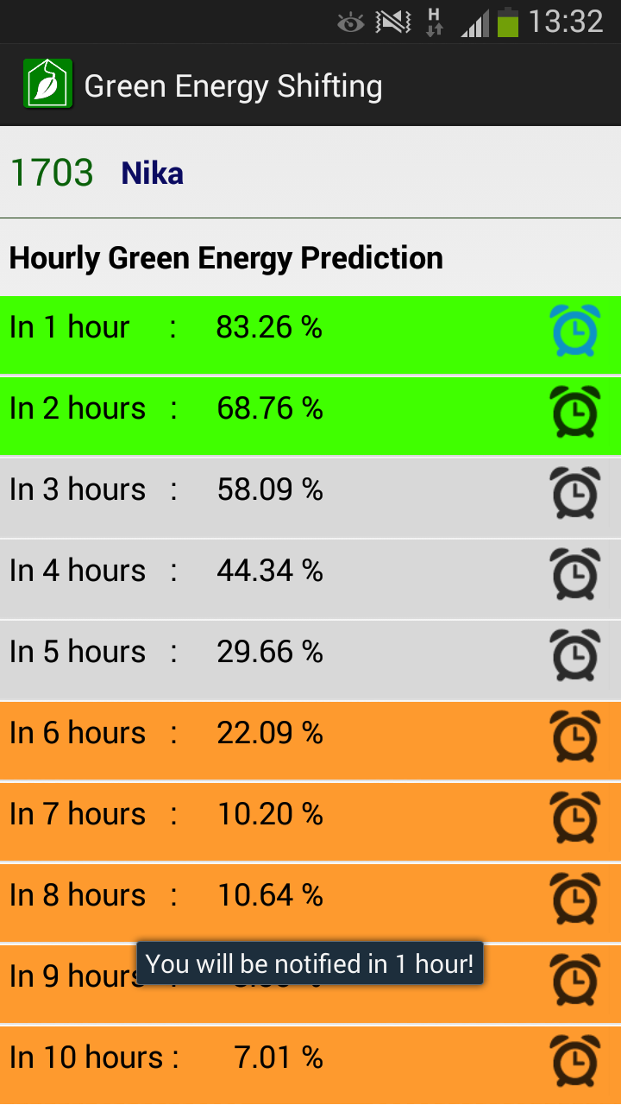

## 4.5. Widget

First, you have to add the widget to your home screen. After doing so, you will see the

chart and the smiley, consistent to the main page of the application. So you get a quick idea whether it is a good time to use energy or not. Background of the widget also changes to green, yellow and red, relative to the amount. At the right bottom, you can see time and date.

The widget is updated every 30 minutes, but you can also refresh it using the icon at the bottom. By clicking on the widget, the application would be opened.

